**Misleading Visualization Scavenger Hunt**

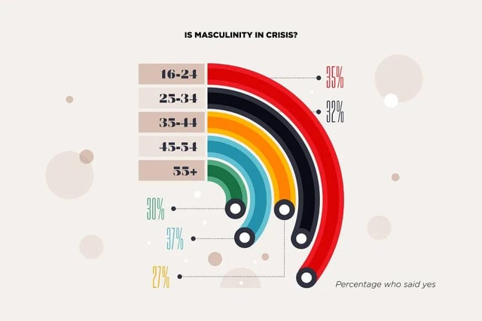

<https://www.reddit.com/r/dataisugly/comments/1i2o1so/ok_so_ages_1624_feel_the_worst_about_masculinity/>

This data comes from a survey asking participants, “Is Masculinity in Crisis?”. Respondents were divided into age groups, and the percentage of each group that answered "yes" was compared. However, the original visualization is misleading. It gives the impression that longer lines correspond to higher percentages, when in fact the lines’ endpoints are angled differently relative to a central point. The higher the angle, the greater the percentage of "yes" responses. Most viewers are likely to glance at the graph without scrutinizing the details, leading them to assume that younger participants overwhelmingly believed masculinity is in crisis compared to older groups. In reality, the percentages across all age groups are relatively similar.

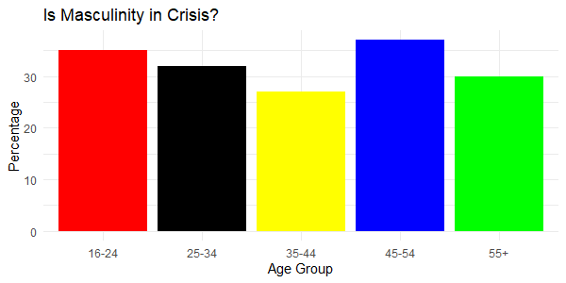

I transformed the original visualization into a straightforward bar chart. While the new graph may be less visually striking, it presents the data in a clearer and more digestible manner for the reader. This approach highlights the truth more effectively. The updated chart clearly demonstrates that the 45-54 age group had the highest percentage of respondents who believe masculinity is in crisis. By aligning the bars for each age group at the same starting point, the chart makes comparisons simpler and more intuitive.

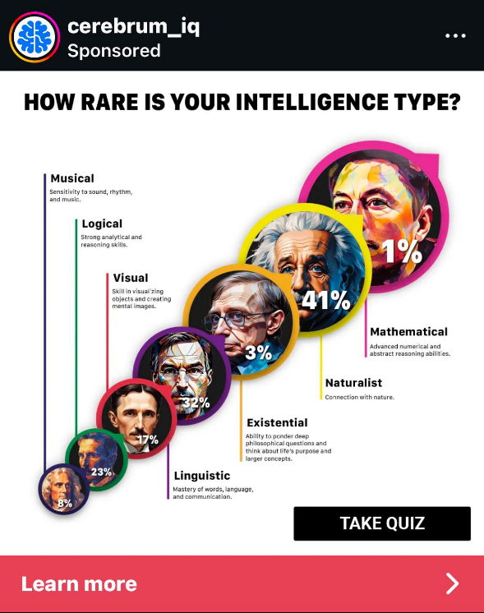

<https://www.reddit.com/r/dataisugly/comments/1hpufj6/how_rare_is_your_intelligence_type/#lightbox>

This visualization depicts the likelihood of having each intelligence type, accompanied by descriptions for each. Its primary goal is to capture readers’ interest and encourage them to take the quiz to discover their intelligence type. However, the graphic is misleading because the types are not arranged in order from least to most common, and the sizes of the bubbles do not accurately correspond to the percentages they represent. It appears the creator prioritized making the most appealing intelligence types more prominent to highlight their "desirability" rather than accurately reflecting their rarity. The percentages also do not add up to 100 percent.

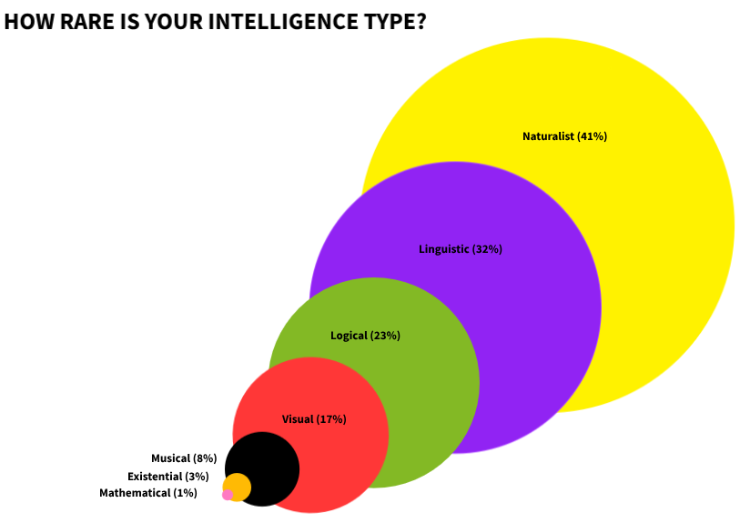

I redesigned the graphic to put the intelligence types in order by size as well as making the bubbles representing them proportional to their percentage. Readers will now easily be able to tell that the Mathematical intelligence type is the rarest and Naturalist is the most common.